|  |  |
| --- | --- |
|  | **2022** |



*COLLEGE OF ELECTRICAL AND MECHANICAL ENGINEERING*

*DEPARTMENT OF SOFTWARE ENGINEERING*

Internet Programming

User manual guide

Section C

**GROUP MEMBERS** **ID**

1. Tsedey Mekonnen ETS1050/12
2. Meron Abera ETS0451/12
3. Meron Edea ETS0450/12
4. Okitta Ongaye ETS0555/12
5. Rediet Berhane ETS0563/12
6. Paulos Teshome ETS0556/12

**Submitted to: Instructor Chere Lemma**

# About the Project

This project proposes an online restaurant website that helps communication between all teams within a restaurant by minimizing the probability of human errors, providing an online table and event reservation, food ordering including delivery as an option.

# How to install and run the website

**Step 1:** Download the Document in a zip file and unzip it in a xampp server htdocs folder.

**Step 2:** Download the mysteriadb.sql database and import it in the phpmyadmin in the xampp server.

The database has the following credentials:

* hostname=’localhost’
* username=’root’
* password=’’
* database name=’mysteriadb’

**Step 3:** Open the index.php file.

**Step 4:** Download phpmailer using composer.exe. and save it in C:xampp/composer/.

Please set the following variables as written, in sendemail.ini in xampp/sendemail directory

auth_username=restauranttmysteria@gmail.com

auth_password=@Mysteria#2

force_sender=restauranttmysteria@gmail.com

**Step 5:** Run the website in any browser using your localhost (i.e. localhost/Mysteria).

# Special accounts

The admin account

* User-name: Rediet Berhane
* Password: ‘red1234’

You can create new account for user

# How to use the website

Opening the index.php file you will get this page after some given seconds it will redirect you to the sign up page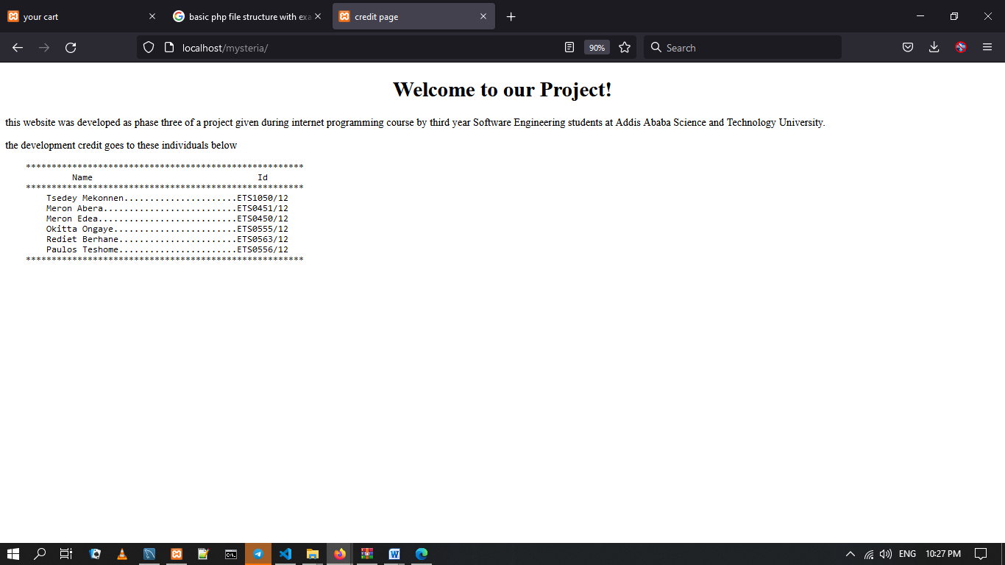

Then you need to register to the website using this form when you register you will receive an account verification link through your email.

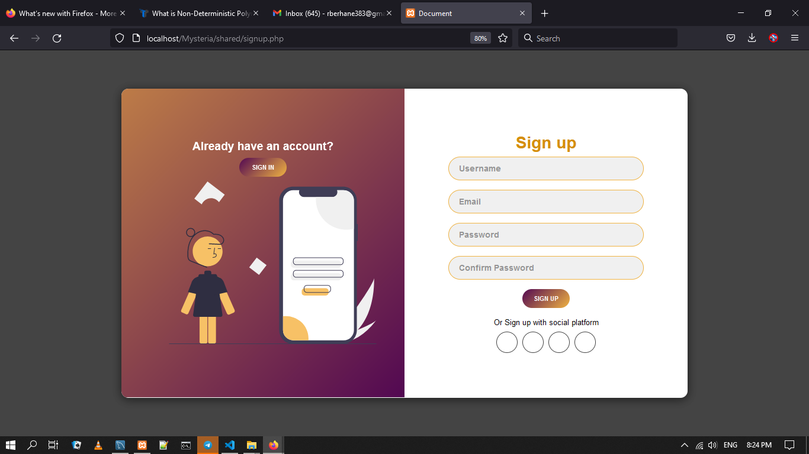

After verifying your email log in to the website using the sign in form.

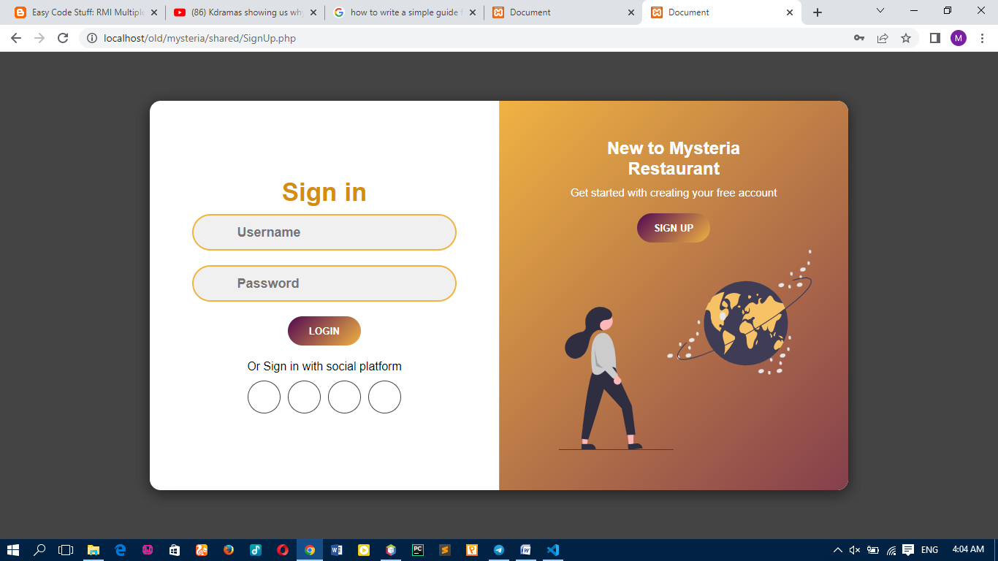

Step 3: If you log in successfully, since you are a customer it will take you to user home page that looks like this.

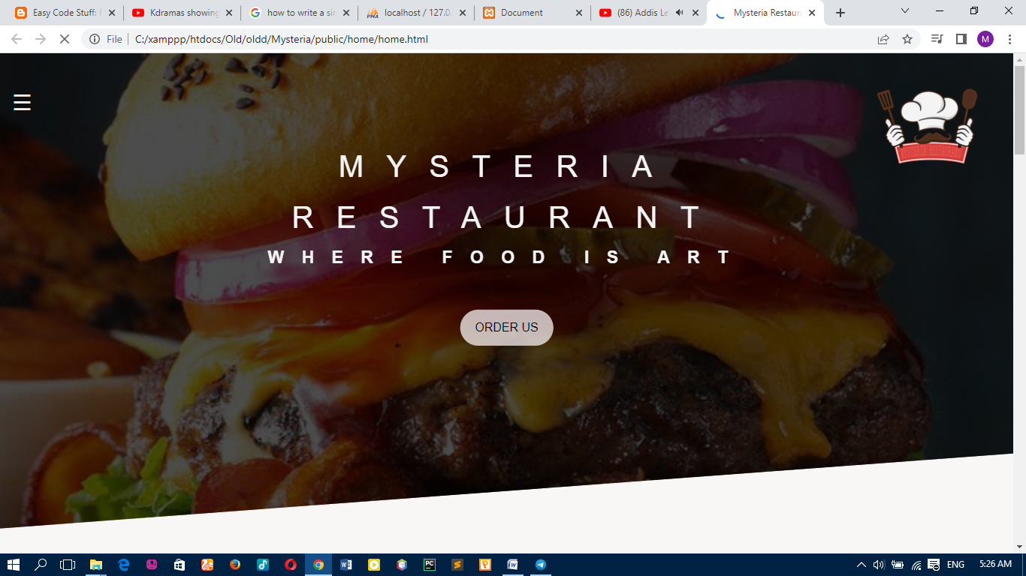

You can navigate through the website services through the navigation bar on the left.

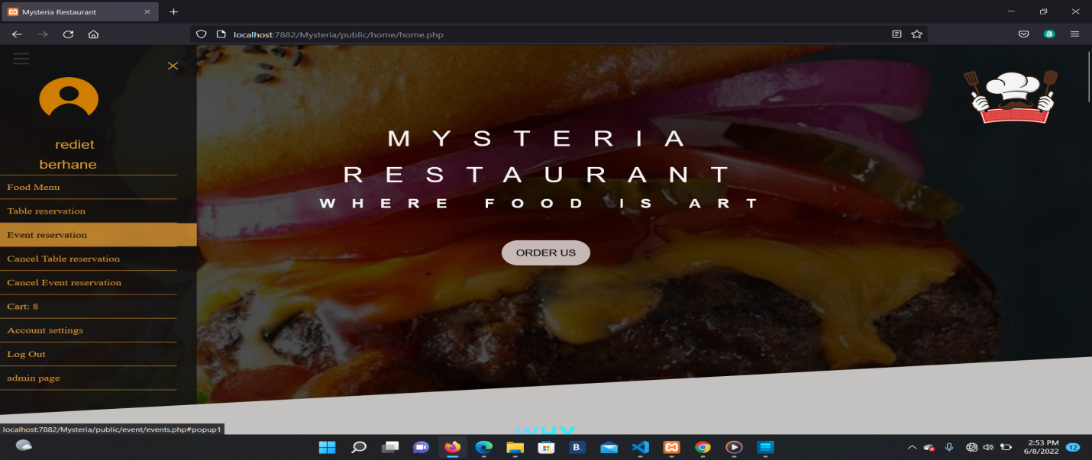

Let’s see food menu, food menu looks like this then we can choose category of what we want to order

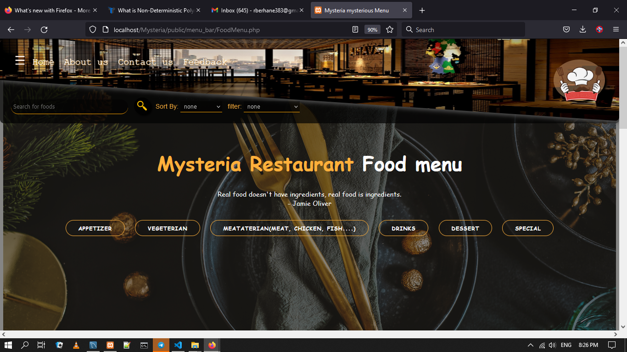

In the category selected you’ll see list of cards with food names food picture and food ingredients inside each card there is an add to cart option you can individually add to cart or select multiple items and then add to cart using the button “add selected items to cart ” on the right.

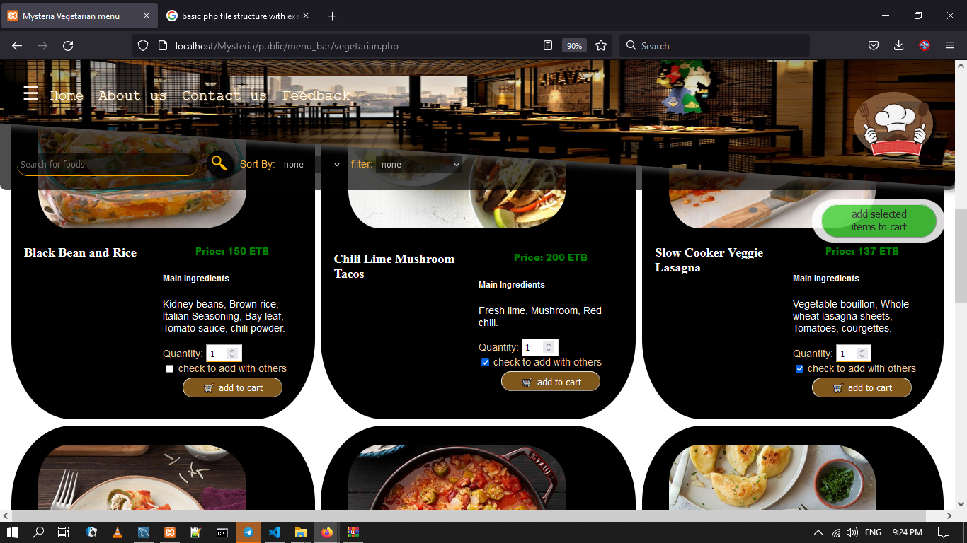

You can see the items you added to cart in the cart page which can be found in the side navigation you can also see the number of items found in your cart there.

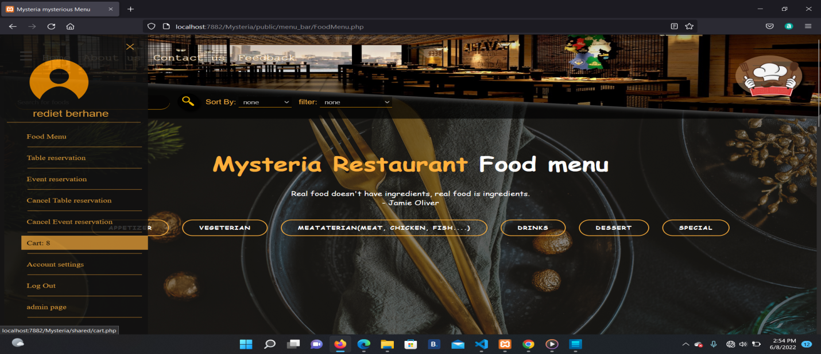

Inside the cart page there will be the items that you selected you can add quantity, remove item, order item either individually or collectively to be delivered or not.

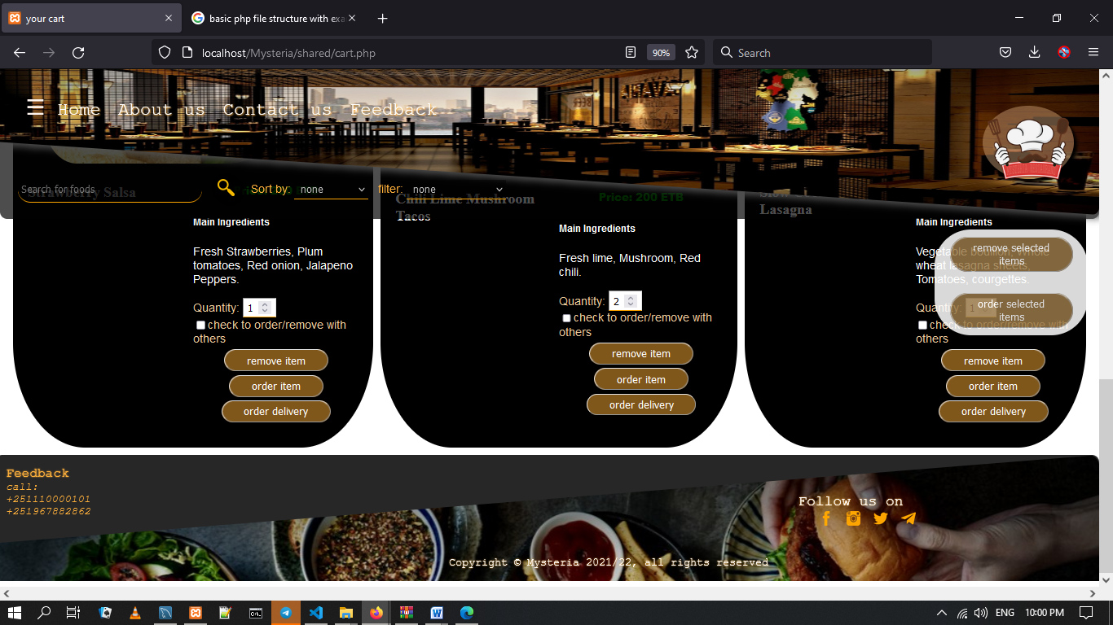

Another feature will be the account setting where you can edit your account settings and search for account by inserting your credientials.

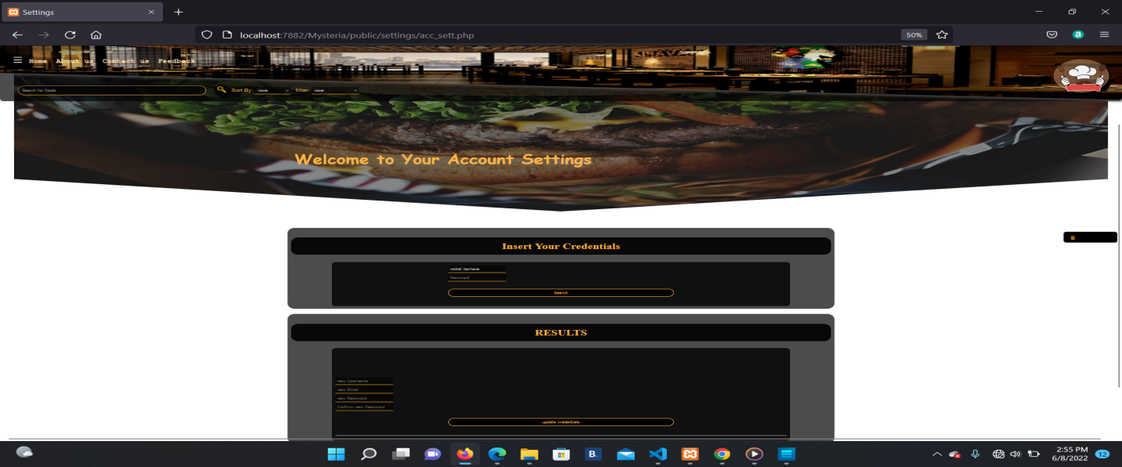

Then you can update your credentials.

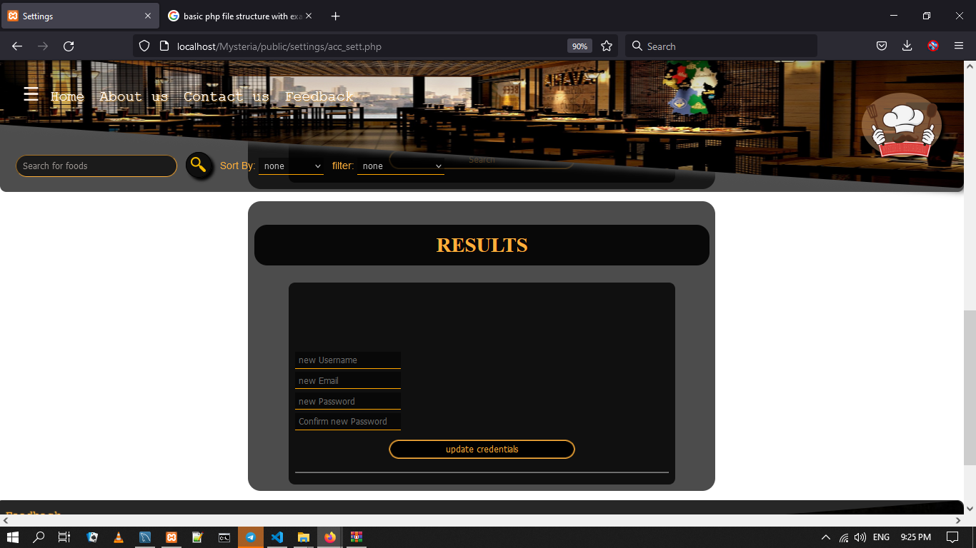

Finally if you finish, you can log out using log out link inside the side navigation.

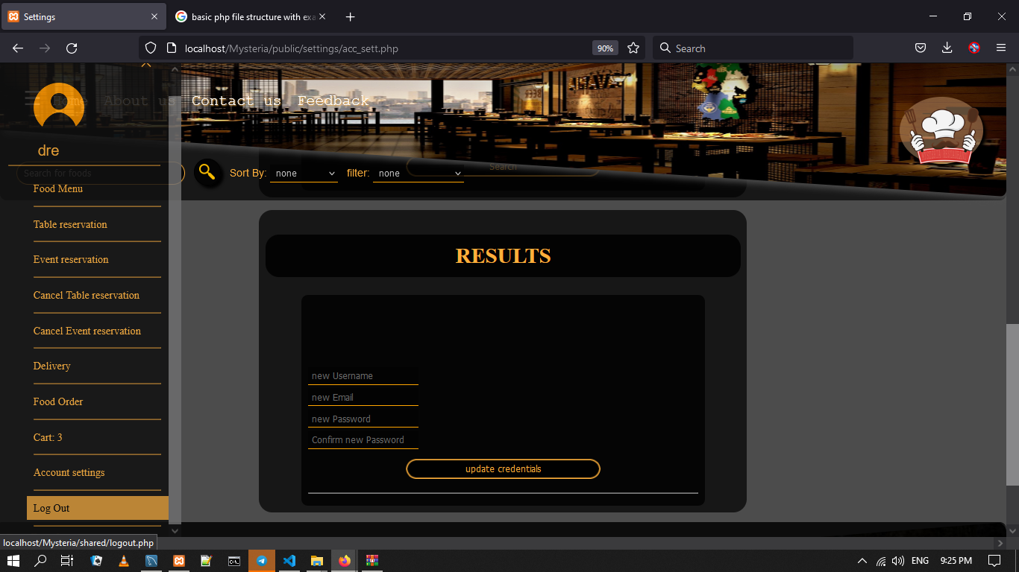

If the account you entered while signing in is admin’s account you will be redirected to the admin page,

Where you can export data from the database, add another admin, add menu… .

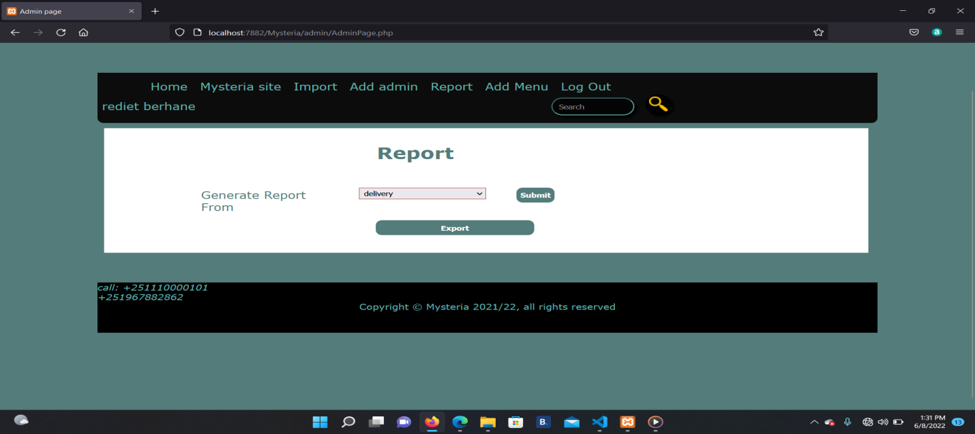

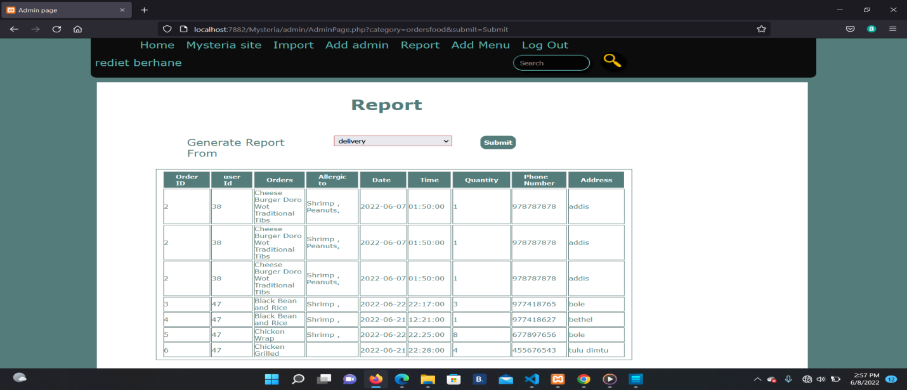

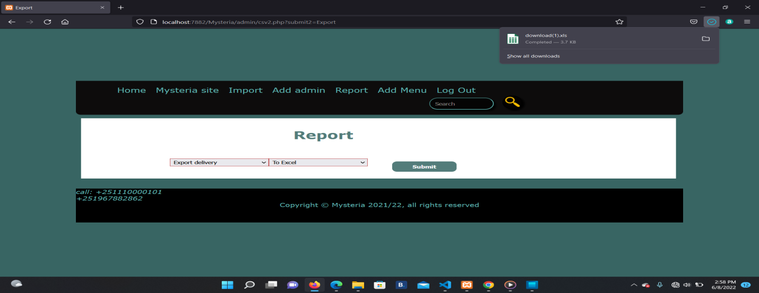

In addition to export you can import data, add additional admin, add food to menu, and report of orders regarding popular foods of the restaurants.

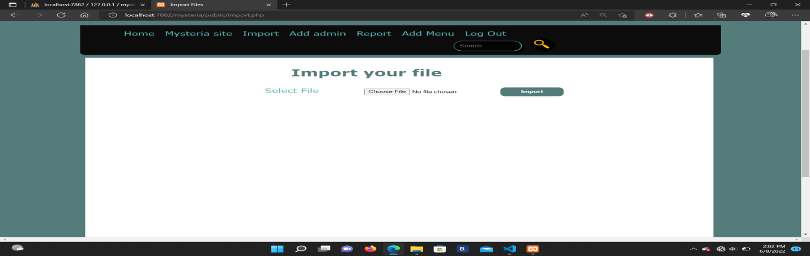

For importing demonstration we have attached the “importdemo.xlsx” file in our root directory

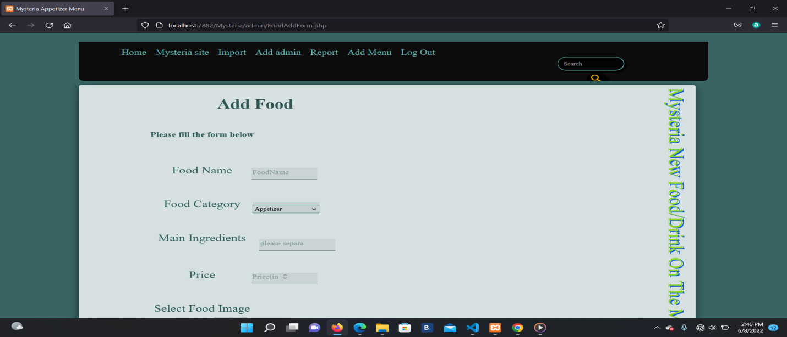

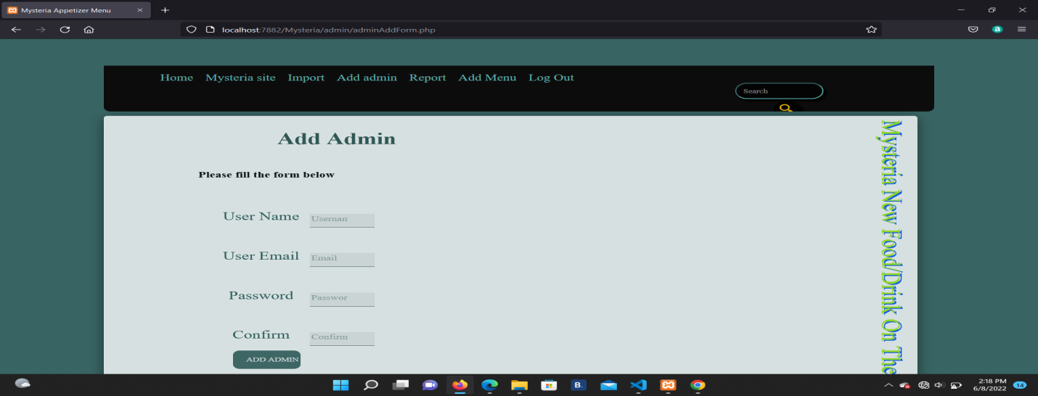

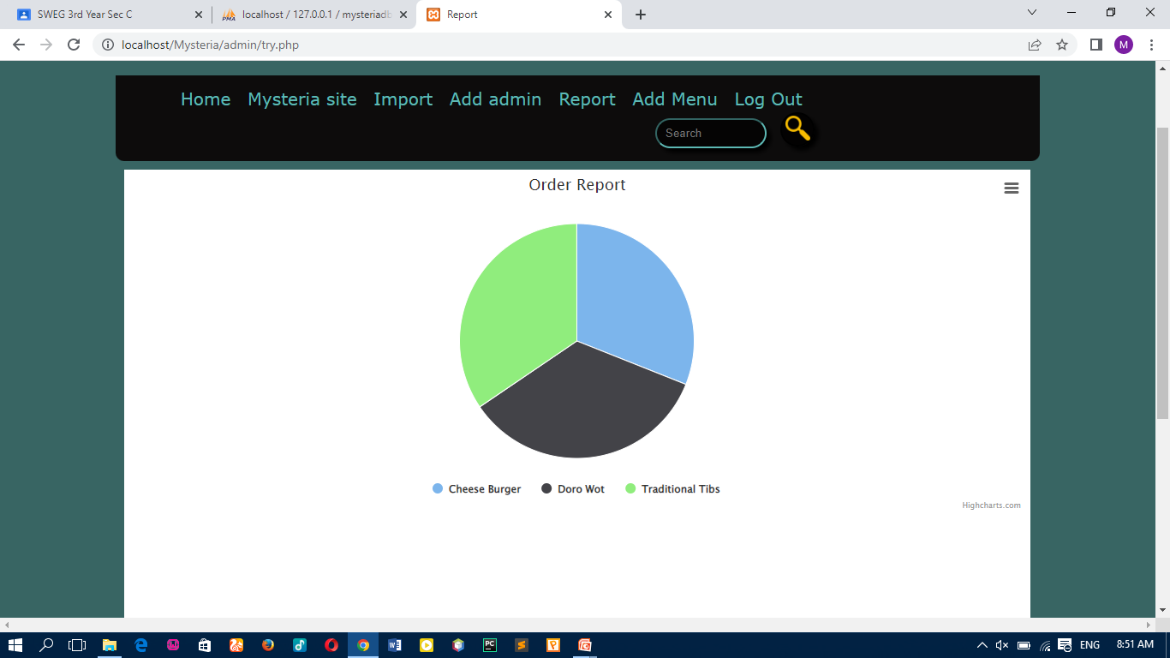

# Team Members Contribution

1. **Tsedey Mekonnen**: Contact us, About us, Feedback, search header, searching, report, CSS of Contact us About us Feedback
2. **Meron Abera**: Event reservation, Excel, Csv, Export, header2, header, footer, Chart, Csv2, CSS of Event Reservation
3. **Meron Edea**: Food Menu, Admin, Import, event header, show menu, foodAddForm.php, CSS of Food Menu
4. **Okitta Ongaye**: Home, Js, registeration, logout, AdminPage, CSS of Home page, CSS of delivery
5. **Rediet Berhane**: reservation, Add to cart.php, cart.php, mail, newFoodConnector.php, CSS of reservation
6. **Paulos Teshome**: Table reservation, Controller, order, setting, Check login and check signup, adminAddForm.php, CSS of table Reservation

# Limitations

Due to time constraints and busy schedule we were unable to complete the following tasks to full standard:

* A complete filter and sanitization in all pages
* Charts need internet connection to work.
* Phpmailer has difficulties since gmail has updated its less secure app setting.
* Reports in pdf format prints onlyone user information of the needed data unlike excel.
* Web Browsers highly affects the layout of the website specifically the vertical appearance of “Mysteria New food menu” in add new food (admin) page.